UNITED STATES

SECURITIES AND EXCHANGE COMMISSION
WASHINGTON, DC 20549

FORM 8-K

CURRENT REPORT

Pursuant to Section 13 OR 15(d)

of The Securities Exchange Act of 1934

Date of report (Date of earliest event reported): June 30, 2023

AGRIFY CORPORATION

(Exact name of registrant as specified in its charter)

Nevada |  |  | 001-39946 |  |  | 30-0943453
(State or other jurisdiction |  |  | (Commission File Number) |  |  |  | (IRS Employer
of incorporation) |  |  |  |  |  |  | Identification No.)
76 Treble Cove Rd.
Building 3
Billerica, MA 01862 |  |  |  |  |  | 01862
(Address of principal executive offices) |  |  |  |  |  |  | (Zip Code)

Registrant’s telephone number, including area code: (617) 896-5243

Check the appropriate box below if the Form 8-K filing is intended to simultaneously satisfy the filing obligation of the registrant under any of the following provisions:

- Written communications pursuant to Rule 425 under the Securities Act (17 CFR 230.425)

- Soliciting material pursuant to Rule 14a-12 under the Exchange Act (17 CFR 240.14a-12)

- Pre-commencement communications pursuant to Rule 14d-2(b) under the Exchange Act (17 CFR 240.14d-2(b))

- Pre-commencement communications pursuant to Rule 13e-4(c) under the Exchange Act (17 CFR 240.13e-4(c)) Securities registered pursuant to Section 12(b) of the Act:

Title of each class |  | Trading symbol(s) |  | Name of each exchange on which registered
Common Stock, par value $0.001 per share |  | AGFY |  | The Nasdaq Stock Market LLC

Indicate by check mark whether the registrant is an emerging growth company as defined in Rule 405 of the Securities Act of 1933 (§230.405 of this chapter) or Rule 12b-2 of the Securities Exchange Act of 1934 (§240.12b-2 of this chapter).

Emerging growth company ☒

If an emerging growth company, indicate by check mark if the registrant has elected not to use the extended transition period for complying with any new or revised financial accounting standards provided pursuant to Section 13(a) of the Exchange Act. ☐

Item 3.03. Material Modification to Rights of Security Holders.

The information set forth in Item 5.03 is incorporated herein by reference.

Item 5.03. Amendment to Articles of Incorporation or Bylaws; Change in Fiscal Year.

On June 30, 2023, Agrify Corporation (the “Company”) filed with the Secretary of State of the State of Nevada a Certificate of Change (the “Certificate of Change”) to effect a 1-for-20 reverse stock split of the Company’s common stock, par value $0.001 per share (the “Common Stock”), in which each twenty
- shares of Common Stock issued and outstanding will be combined and converted into one share of Common Stock (the “Reverse Stock Split”). The Reverse Stock Split will be effective as of 12:01 a.m. Eastern Time on July 5, 2023 (the “Effective Date”).

Reason for the Reverse Stock Split

The Company is effecting the Reverse Stock Split to satisfy the $1.00 minimum bid price requirement (the “Minimum Bid Requirement”), as set forth in Nasdaq Listing Rule 5550(a)(2) (the “Rule”), for continued listing on The Nasdaq Capital Market. As previously disclosed, on January 19, 2023, the Company received a letter from the staff of the Listing Qualifications Department of The Nasdaq Stock Market (“Nasdaq”) indicating that for the previous 30 consecutive business days, the closing bid price of the Company’s Common Stock had been below $1.00 per share, the minimum closing bid price required by the Rule for continued listing on the Nasdaq. Also, as previously disclosed, the staff of Nasdaq determined that the Company was eligible for a 180-day period to attempt to regain compliance with the Rule, which will expire on July 18, 2023. To regain compliance with the Rule, the closing bid price of the Company’s Common Stock must be at least $1.00 per share for a minimum 10 consecutive business days.

Effects of the Reverse Stock Split

Effective Date; Symbol; CUSIP Number. The Reverse Stock Split becomes effective with Nasdaq, and the Common Stock will begin trading on a split-adjusted basis, at the opening of business on the Effective Date. In connection with the Reverse Stock Split, the CUSIP number for the Common Stock will change to 00853E305. The trading symbol for the Common Stock will remain “AGFY.”

Split Adjustment; Treatment of Fractional Shares. On the Effective Date, the total number of shares of Common Stock held by each stockholder of the Company will be converted automatically into the number of shares of Common Stock equal to: (i) the number of issued and outstanding shares of Common Stock held by each such record holder immediately prior to the Reverse Stock Split divided by (ii) twenty (20). Any fractional share of Common Stock that would otherwise result from the Reverse Stock Split will be rounded up to the nearest whole share. As a result, no fractional shares will be issued in connection with the Reverse Stock Split and no cash or other consideration will be paid in connection with any fractional shares that would otherwise have resulted from the Reverse Stock Split.

Book-Entry Shares. When the Reverse Stock Split is effected, stockholders who hold uncertificated shares (i.e., shares held in book-entry form and not represented by a physical stock certificate), either as direct or beneficial owners, will have their holdings electronically adjusted automatically by our transfer agent (and, for beneficial owners, by their brokers or banks that hold in “street name” for their benefit, as the case may be) to give effect to the Reverse Stock Split. Stockholders who hold uncertificated shares as direct owners will be sent a statement of holding from our transfer agent that indicates the number of post-reverse stock split shares of our Common Stock owned in book-entry form.

Certificated Shares. As soon as practicable after the effective time of the Reverse Stock Split, stockholders will be notified that the Reverse Stock Split has been effected. Our transfer agent, Broadridge Corporate Issuer Solutions, LLC, will act as exchange agent for purposes of implementing the exchange of stock certificates. Holders of pre-split shares will be asked to surrender to the exchange agent certificates representing pre-split shares in exchange for certificates representing post-split shares in accordance with the procedures to be set forth in a letter of transmittal to be sent by us or our exchange agent. No new certificates will be issued to a stockholder until such stockholder has surrendered such stockholder’s outstanding certificate(s) together with the properly completed and executed letter of transmittal to the exchange agent. Any pre-split shares submitted for transfer, whether pursuant to a sale or other disposition, or otherwise, will automatically be exchanged for post-split shares.

1

Stockholders should not destroy any stock certificate(s) and should not submit any certificate(s) until requested to do so.

Treatment of Convertible Securities and Equity Awards. On the Effective Date, all options and other convertible securities of the Company outstanding immediately prior to the Reverse Stock Split will be adjusted by dividing the number of shares of Common Stock into which the options and other convertible securities are exercisable or convertible by twenty (20) and multiplying the exercise or conversion price thereof by twenty (20), as applicable, all in accordance with the terms of the plans, agreements or arrangements governing such options and other convertible securities and subject to rounding to the nearest whole share. Such proportional adjustments will also be made to the number of shares and restricted stock units issued and issuable under the Company’s equity compensation plan.

Certificate of Change. The Company is effecting the Reverse Stock Split pursuant to the Company’s filing of the Certificate of Change with the Nevada Secretary of State on June 30, 2023, in accordance with Nevada Revised Statutes (“NRS”) section 78.209. The Certificate of Change will become effective at 12:01 a.m. Eastern Time on the Effective Date. A copy of the Certificate of Change is attached hereto as Exhibit 3.1 and is incorporated herein by reference.

No Stockholder Approval Required. The Reverse Stock Split was approved by the Board of Directors of the Company and given effect pursuant to and in accordance with NRS section 78.207 and, as such, no stockholder approval of the Reverse Stock Split is required.

Capitalization. Prior to the Reverse Stock Split, the Company was authorized to issue 200,000,000 shares of Common Stock. As a result of the Reverse Stock Split, the Company will be authorized to issue 10,000,000 shares of Common Stock. As of June 30, 2023, there were 32,458,929 shares of Common Stock outstanding. As a result of the Reverse Stock Split, there will be approximately 1,622,947 shares of Common Stock outstanding. The Reverse Stock Split will not have any effect on the stated par value of the Common Stock.

The Reverse Stock Split does not affect the Company’s authorized preferred stock. There are no outstanding shares of the Company’s preferred stock. After the Reverse Stock Split, the Company’s authorized preferred stock of 3,000,000 shares will remain unchanged.

Immediately after the Reverse Stock Split, each stockholder’s relative ownership interest in the Company and proportional voting power will remain unchanged except for minor changes and adjustments that will result from rounding fractional shares into whole shares.

Item 8.01. Other Events.

On July 3, 2023, the Company issued a press release announcing the effective date of the reverse stock split. A copy of the press release is filed herewith as Exhibit 99.1 and is incorporated herein by reference.

Item 9.01. Financial Statements and Exhibits.

(d) Exhibits.
Exhibit
Number |  | Title
3.1 |  | Certificate of Change to Articles of Incorporation of Agrify Corporation, filed June 30, 2023.
99.1 |  | Press Release of Agrify Corporation, dated as of July 3, 2023.

- Cover Page Interactive Data File (embedded within the Inline XBRL document). 2

SIGNATURES

Pursuant to the requirements of the Securities Exchange Act of 1934, the registrant has duly caused this report to be signed on its behalf by the undersigned hereunto duly authorized.

AGRIFY CORPORATION

Date: July 3, 2023 By: /s/ Raymond Nobu Chang

Raymond Nobu Chang

Chief Executive Officer

3

Exhibit 3.1
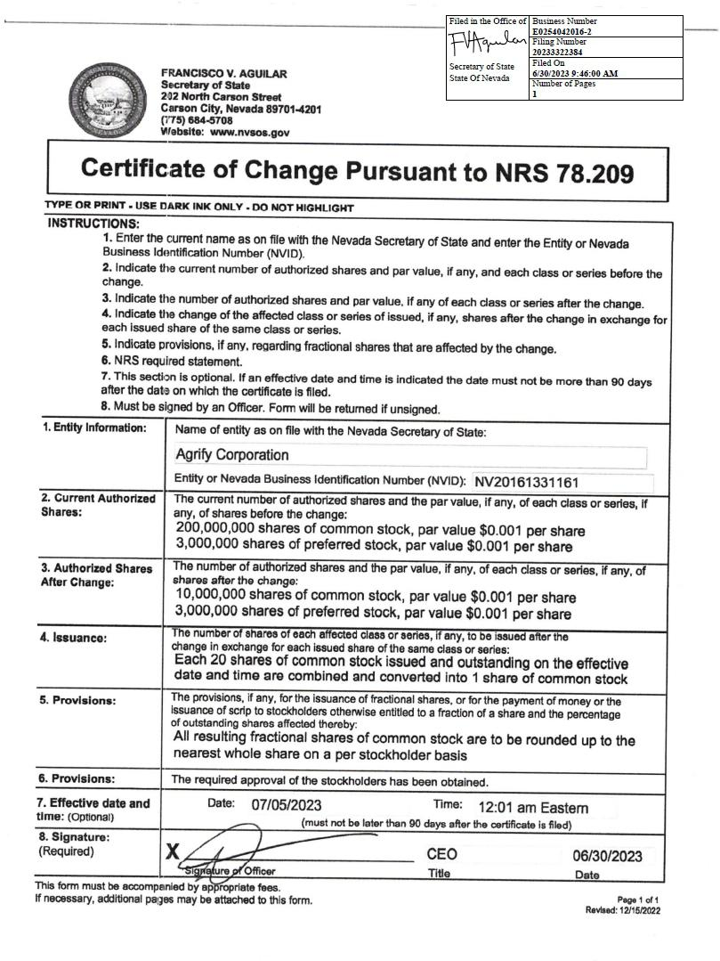

Exhibit 99.1

Agrify Announces 1-For-20 Reverse Stock Split

BILLERICA, Mass., July 3, 2023 (GLOBE NEWSWIRE) -- Agrify Corporation (Nasdaq:AGFY) (“Agrify” or the “Company”), a leading provider of innovative cultivation and extraction solutions for the cannabis industry, today announced that the Company’s Board of Directors approved a 1-for-20 reverse stock split, to be effective as of 12:01 a.m. on Wednesday, July 5, 2023. The Company’s common stock will open for trading on the Nasdaq Capital Market on Wednesday, July 5, 2023 on a split-adjusted basis under the current trading symbol “AGFY.” The reverse stock split is intended to increase the per share trading price of the Company’s common stock to enable the Company to satisfy the minimum bid price requirement for continued listing on the Nasdaq Capital Market.

The 1-for-20 reverse stock split will automatically convert 20 current shares of Agrify’s common stock into one new share of common stock. No fractional shares will be issued in connection with the reverse stock split. Stockholders who would otherwise hold a fractional share of Agrify’s common stock will receive a whole share in lieu thereof. The reverse stock split will reduce the number of shares of outstanding common stock from approximately 32,458,929 shares to approximately 1,622,947 shares. Proportional adjustments also will be made to the exercise prices of Agrify’s outstanding stock options, warrants, shares held back in connection with acquisitions and to the number of shares issued and issuable under Agrify’s equity incentive plans. The reverse stock split will proportionally reduce the number of authorized shares of common stock from 200,000,000 to 10,000,000, but will not change the par value of Agrify’s common stock.

Broadridge Corporate Issuer Solutions, Inc. (“Broadridge”) will act as the exchange agent for the reverse stock split. Stockholders holding their shares electronically in book-entry form are not required to take any action to receive post-split shares. Stockholders owning shares through a bank, broker or other nominee will have their positions automatically adjusted to reflect the reverse stock split, subject to the respective individual brokers’ particular processes, and will not be required to take any action in connection with the reverse stock split.

In connection with the reverse stock split, the CUSIP number for the Company’s common stock will change to 00853E305 as of 12:01 a.m. on Wednesday, July 5, 2023.

About Agrify (Nasdaq:AGFY)

Agrify is a leading provider of innovative cultivation and extraction solutions for the cannabis industry, bringing data, science, and technology to the forefront of the market. Our proprietary micro-environment-controlled Vertical Farming Units (VFUs) enable cultivators to produce high quality products with unmatched consistency, yield, and ROI at scale. Our comprehensive extraction product line, which includes hydrocarbon, ethanol, solventless, post-processing, and lab equipment, empowers producers to maximize the quantity and quality of extract required for premium concentrates. For more information, please visit Agrify at http://www.agrify.com.

Forward-Looking Statements

This press release contains forward-looking statements within the meaning of the Private Securities Litigation Reform Act of 1995 concerning Agrify and other matters. All statements contained in this press release that do not relate to matters of historical fact should be considered forward-looking statements including, without limitation, statements regarding compliance with the minimum bid price requirement and other applicable Nasdaq continued listing standards and the effect of the reverse stock split, including the estimated number of shares of common stock outstanding after effecting the reverse stock split. In some cases, you can identify forward-looking statements by terms such as “may,” “will,” “should,” “expects,” “plans,” “anticipates,” “could,” “intends,” “targets,” “projects,” “contemplates,” “believes,” “estimates,” “predicts,” “potential” or “continue” or the negative of these terms or other similar expressions. The forward-looking statements in this press release are only predictions. Agrify has based these forward-looking statements largely on its current expectations and projections about future events and financial trends that it believes may affect its business, financial condition and results of operations. Forward-looking statements involve known and unknown risks, uncertainties and other important factors that may cause our actual results, performance or achievements to be materially different from any future results, performance or achievements expressed or implied by the forward-looking statements. You should carefully consider the risks and uncertainties that affect our business, including those described in our filings with the Securities and Exchange Commission (“SEC”), including under the caption “Risk Factors” in our Annual Report on Form 10-K filed for the year ended December 31, 2021 with the SEC, which can be obtained on the SEC website at www.sec.gov. These forward-looking statements speak only as of the date of this communication. Except as required by applicable law, we do not plan to publicly update or revise any forward-looking statements, whether as a result of any new information, future events or otherwise. You are advised, however, to consult any further disclosures we make on related subjects in our public announcements and filings with the SEC.

Company Contacts

Investor Relations and Media Inquiries

Caitlin Bricker

Chief of Staff

caitlin.bricker@agrify.com

- 733-0584 Source: Agrify

