UNITED STATES

SECURITIES AND EXCHANGE COMMISSION

WASHINGTON, DC 20549

FORM 8-K

CURRENT REPORT

Pursuant to Section 13 OR 15(d)

of The Securities Exchange Act of 1934

Date of report (Date of earliest event reported): October 14, 2022

AGRIFY CORPORATION

(Exact name of registrant as specified in its charter)

Nevada |  |  | 001-39946 |  |  |  | 30-0943453
(State or other jurisdiction |  |  | (Commission File Number) |  |  |  | (IRS Employer
of incorporation) |  |  |  |  |  |  | Identification No.)
76 Treble Cove Rd.
Building 3
Billerica, MA 01862 |  |  |  |  |  |  | 01862
(Address of principal executive offices) |  |  |  |  |  |  | (Zip Code)

Registrant’s telephone number, including area code: (617) 896-5243

Check the appropriate box below if the Form 8-K filing is intended to simultaneously satisfy the filing obligation of the registrant under any of the following provisions:

- Written communications pursuant to Rule 425 under the Securities Act (17 CFR 230.425)

- Soliciting material pursuant to Rule 14a-12 under the Exchange Act (17 CFR 240.14a-12)

- Pre-commencement communications pursuant to Rule 14d-2(b) under the Exchange Act (17 CFR 240.14d-2(b))

- Pre-commencement communications pursuant to Rule 13e-4(c) under the Exchange Act (17 CFR 240.13e-4(c)) Securities registered pursuant to Section 12(b) of the Act:

Title of each class |  | Trading symbol(s) |  | Name of each exchange on which registered
Common Stock, par value $0.001 per share |  | AGFY |  | The Nasdaq Stock Market LLC

Indicate by check mark whether the registrant is an emerging growth company as defined in Rule 405 of the Securities Act of 1933 (§230.405 of this chapter) or Rule 12b-2 of the Securities Exchange Act of 1934 (§240.12b-2 of this chapter).

Emerging growth company ☒

If an emerging growth company, indicate by check mark if the registrant has elected not to use the extended transition period for complying with any new or revised financial accounting standards provided pursuant to Section 13(a) of the Exchange Act. ☐

Item 3.03. Material Modification to Rights of Security Holders.

The information set forth in Item 5.03 is incorporated herein by reference.

Item 5.03. Amendment to Articles of Incorporation or Bylaws; Change in Fiscal Year.

On October 14, 2022, Agrify Corporation (the “Company”) filed with the Secretary of State of the State of Nevada a Certificate of Amendment to the Company’s Articles of Incorporation (the “Certificate of Amendment”), which was approved by the Company’s stockholders at a Special Meeting of Stockholders of the Company held on October 14, 2022 (the “Special Meeting”) and by the Company’s Board of Directors.

The Certificate of Amendment effects a 1-for-10 reverse stock split of the Company’s common stock, par value $0.001 per share (the “Common Stock”), in which each ten (10) shares of Common Stock issued and outstanding as of 12:01 a.m. Pacific Time on October 18, 2022 (the effective time of the reverse stock split) will be combined and converted into one share of Common Stock. While the reverse stock split will decrease the number of outstanding shares of Common Stock, it will not change the total number of shares of Common Stock authorized for issuance by the Company, nor will it change the par value of the Common Stock. The reverse stock split is primarily intended to bring the Company into compliance with the minimum bid price requirement for maintaining its listing on The Nasdaq Capital Market.

No fractional shares of Common Stock will be issued in connection with the reverse stock split. Instead, stockholders who would otherwise hold a fractional share of Common Stock will receive a whole share in lieu thereof.

This summary of the Certificate of Amendment is qualified in its entirety by reference to the Certificate of Amendment, a copy of which is attached hereto as Exhibit 3.1 and incorporated by reference herein.

The Company expects that the reverse stock split-adjusted shares of its Common Stock will begin trading on The Nasdaq Capital Market at the open of the market on October 18, 2022 under the new CUSIP number 00853E206. No change will be made to the trading symbol for the Common Stock, “AGFY”, in connection with the reverse stock split.

In connection with the reverse stock split, proportional adjustments will be made to (i) the number of shares of Common Stock underlying the Company’s outstanding stock options and warrants, (ii) the exercise price or conversion price (as applicable) of the Company’s outstanding stock options and warrants, and (iii) the number of shares reserved for issuance under the Company’s equity incentive plan.

Item 5.07 Submission of Matters to a Vote of Security Holders

On October 14, 2022, the Company held the Special Meeting virtually, commencing at 10:00 a.m. Eastern Time. Of the Company’s 26,678,477 shares of common stock issued and outstanding and eligible to vote as of the record date of September 6, 2022, a quorum of 14,894,954 shares, or approximately 55.83% of the eligible shares, were represented at the virtual Special Meeting either in person or by proxy.

A description of each matter voted upon at the Special Meeting is described in detail in the Company’s definitive proxy statement filed with the Securities and Exchange Commission on September 19, 2022 (the “Proxy Statement”). The matters voted upon at the Special Meeting and the final results of such voting are set forth below:

1

Proposal 1 – Approval of Issuance of Shares Upon Exercise of Warrants

The issuance of up to 21,108,751 shares of Common Stock upon the exercise of warrants of the Company (the “Warrants”) issued in connection with the issuance of a senior secured note and the exchange of previously issued warrants in August 2022, and the reduction of the exercise price of certain of those Warrants under certain circumstances, was approved. The results of the vote were as follows:

Votes For |  | Votes Against |  | Votes Abstained |  | Broker Non-Votes
6,772,215 |  | 660,444 |  | 52,681 |  | 7,409,614

Proposal 2 – Approval of Reverse Stock Split Authority

An amendment to the Company’s Articles of Incorporation to effect a reverse stock split of the shares of the Company’s Common Stock at a ratio of not less than 1-for-2 and not greater than 1-for-10, with the exact ratio of, effective time of and decision to implement the reverse stock split to be determined by the Board of Directors, was approved. The results of the vote were as follows:

Votes For |  | Votes Against |  | Votes Abstained
13,985,128 |  | 773,798 |  | 136,028

Proposal 3 – Adjournment of Special Meeting

The adjournment of the Special Meeting in order to solicit additional proxies if there are not sufficient shares to be voted in favor of any of the foregoing proposals at the time of the Special Meeting, was approved, although no such adjournment was required due to the approval of Proposals 1 and 2. The results of the vote were as follows:

Votes For |  | Votes Against |  | Votes Abstained
13,549,277 |  | 1,187,352 |  | 158,325
Item 8.01. Other Events.

On October 17, 2022, the Company issued a press release announcing the effective date of the reverse stock split. A copy of the press release is filed herewith as Exhibit 99.1 and is incorporated herein by reference.

Item 9.01. Financial Statements and Exhibits.

(d) Exhibits.
Exhibit
Number |  | Title
3.1 |  | Certificate of Amendment to Articles of Incorporation of Agrify Corporation, filed October 14, 2022.
99.1 |  | Press Release of Agrify Corporation, dated as of October 17, 2022.

- Cover Page Interactive Data File (embedded within the Inline XBRL document). 2

SIGNATURES

Pursuant to the requirements of the Securities Exchange Act of 1934, the registrant has duly caused this report to be signed on its behalf by the undersigned hereunto duly authorized.

AGRIFY CORPORATION

Date: October 17, 2022 By: /s/ Timothy R. Oakes

Timothy R. Oakes

Chief Financial Officer

3

Exhibit 3.1
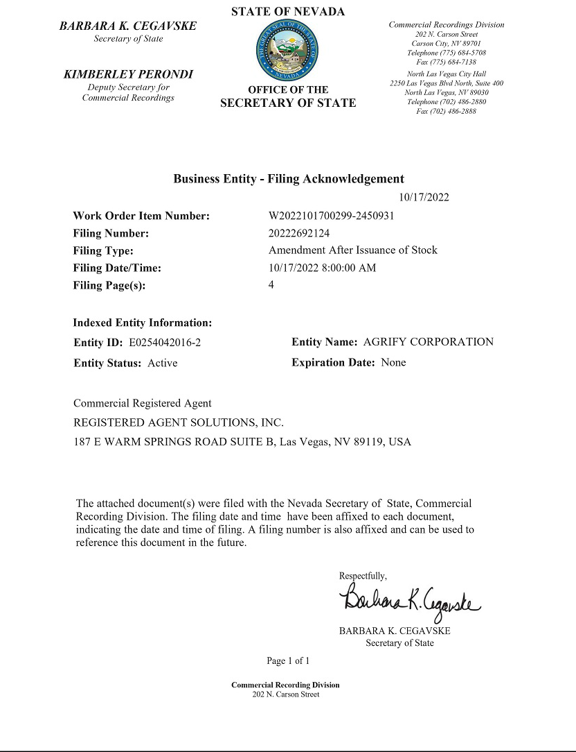

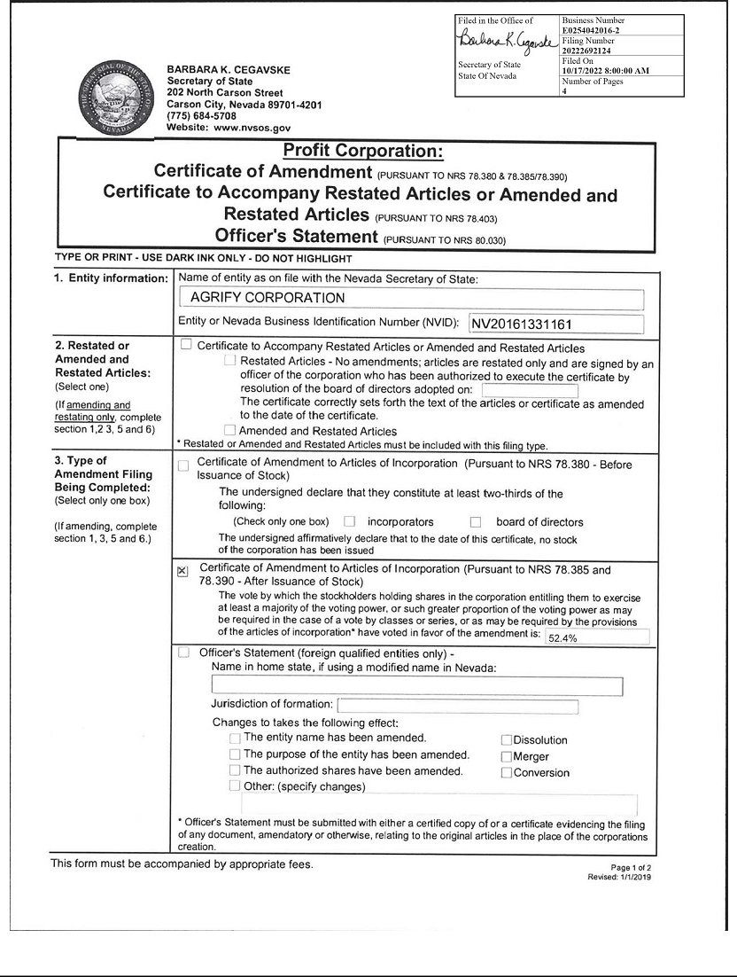

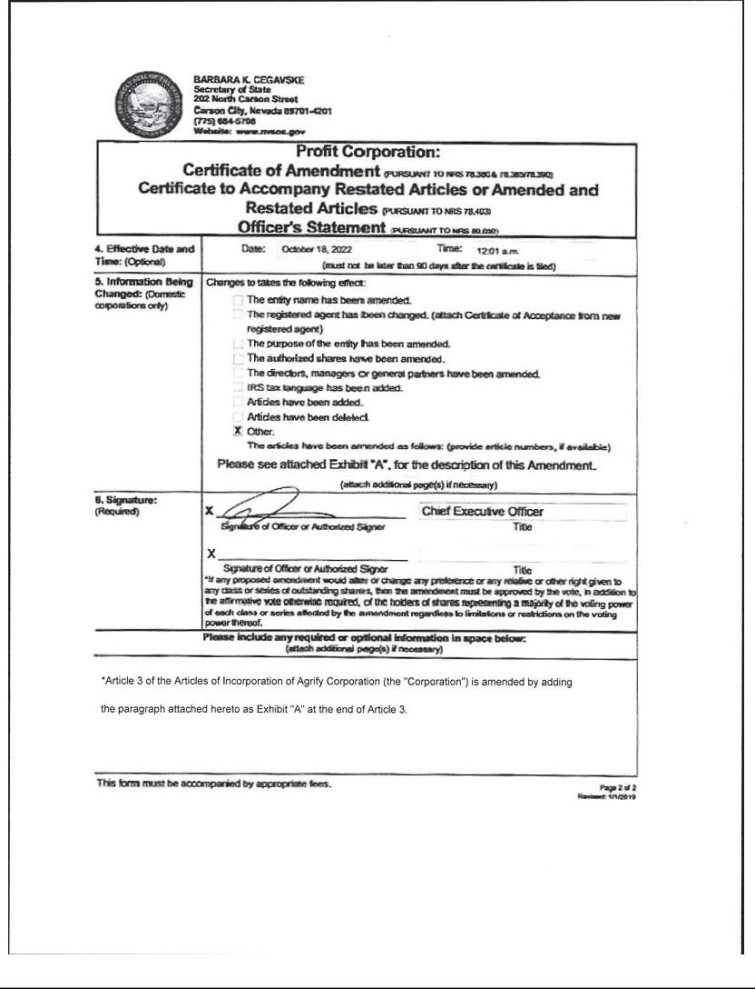

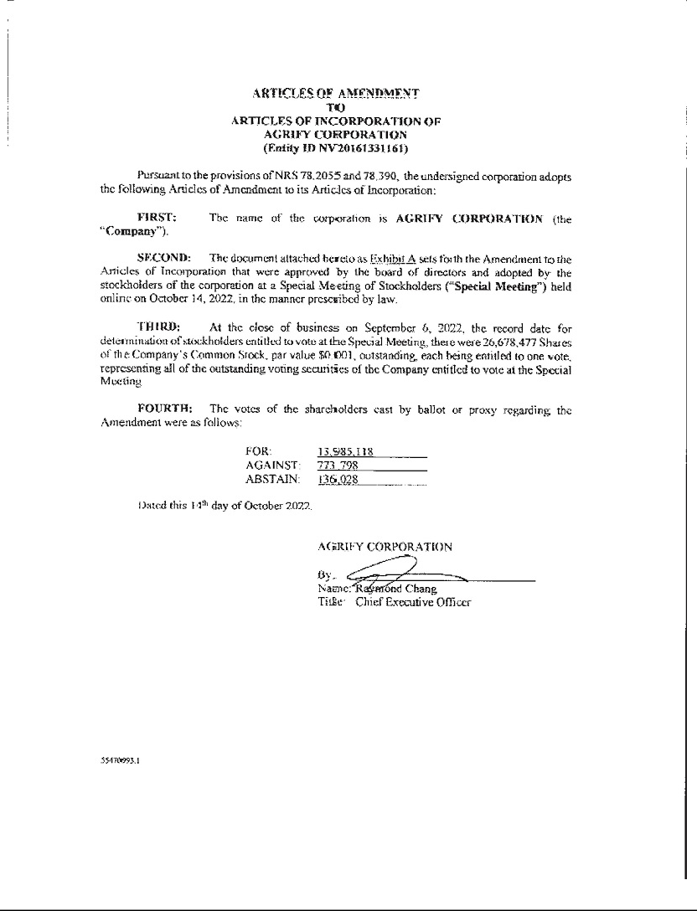

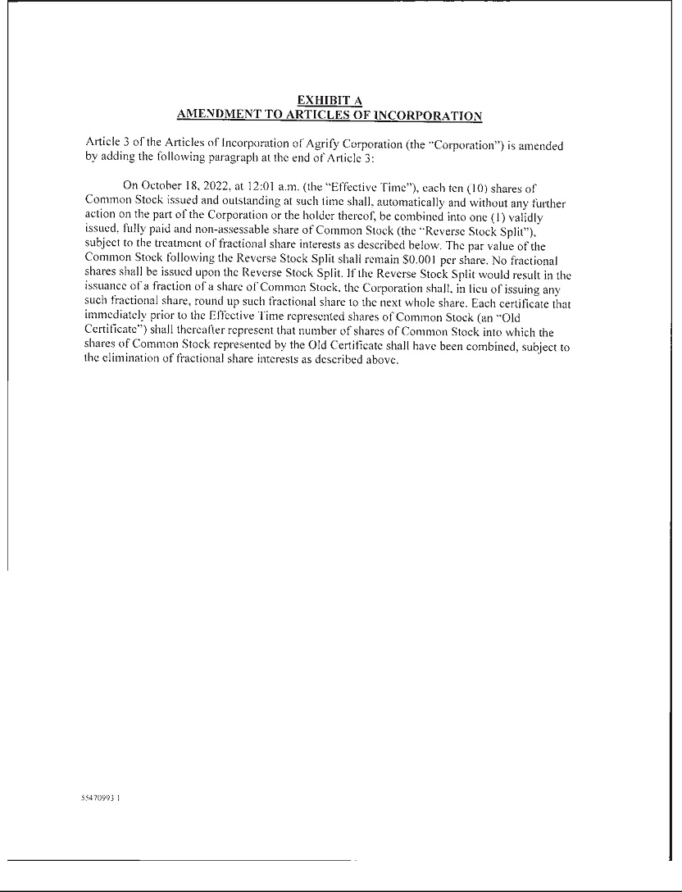

Exhibit 99.1

AGRIFY ANNOUNCES 1-FOR-10 REVERSE STOCK SPLIT

BILLERICA, Mass., October 17, 2022 - Agrify Corporation (Nasdaq:AGFY) (“Agrify” or the “Company”), a leading provider of innovative cultivation and extraction solutions for the cannabis industry, today announced that the Company’s Board of Directors approved a 1-for-10 reverse stock split, to be effective as of 12:01 a.m. on Tuesday, October 18, 2022. The Company’s common stock will open for trading on the Nasdaq Capital Market on Tuesday, October 18, 2022 on a split-adjusted basis under the current trading symbol “AGFY.” The reverse stock split was approved by the Company’s stockholders on October 14, 2022 and is intended to increase the per share trading price of the Company’s common stock to enable the Company to satisfy the minimum bid price requirement for continued listing on the Nasdaq Capital Market.

The 1-for-10 reverse stock split will automatically convert 10 current shares of Agrify’s common stock into one new share of common stock. No fractional shares will be issued in connection with the reverse stock split. Stockholders who would otherwise hold a fractional share of Agrify’s common stock will receive a whole share in lieu thereof. The reverse stock split will reduce the number of shares of outstanding common stock from approximately 26,710,087 shares to approximately 2,671,009 shares. Proportional adjustments also will be made to the exercise prices of Agrify’s outstanding stock options, warrants, shares held back in connection with recently completed acquisitions and to the number of shares issued and issuable under Agrify’s equity incentive plans. The reverse stock split will not change the par value of Agrify’s common stock and will not reduce the number of authorized shares of common stock.

Broadridge Corporate Issuer Solutions, Inc. (“Broadridge”) will act as the exchange agent for the reverse stock split. Stockholders holding their shares electronically in book-entry form are not required to take any action to receive post-split shares. Stockholders owning shares through a bank, broker or other nominee will have their positions automatically adjusted to reflect the reverse stock split, subject to the respective individual brokers’ particular processes, and will not be required to take any action in connection with the reverse stock split.

In connection with the reverse stock split, the Company’s CUSIP number will change to 00853E206 as of 12:01 a.m. on Tuesday, October 18, 2022.

About Agrify (Nasdaq:AGFY)

Agrify is a leading provider of innovative cultivation and extraction solutions for the cannabis industry, bringing data, science, and technology to the forefront of the market. Our proprietary micro-environment-controlled Vertical Farming Units (VFUs) enable cultivators to produce the highest quality products with unmatched consistency, yield, and ROI at scale. Our comprehensive extraction product line, which includes hydrocarbon, ethanol, solventless, post-processing, and lab equipment, empowers producers to maximize the quantity and quality of extract required for premium concentrates. For more information, please visit Agrify at http://www.agrify.com.

Forward-Looking Statements

This press release contains forward-looking statements within the meaning of the Private Securities Litigation Reform Act of 1995 concerning Agrify and other matters. All statements contained in this press release that do not relate to matters of historical fact should be considered forward-looking statements including, without limitation, statements regarding compliance with the minimum bid price requirement and other applicable Nasdaq continued listing standards and the effect of the reverse stock split, including the estimated number of shares of common stock outstanding after effecting the reverse stock split. In some cases, you can identify forward-looking statements by terms such as “may,” “will,” “should,” “expects,” “plans,” “anticipates,” “could,” “intends,” “targets,” “projects,” “contemplates,” “believes,” “estimates,” “predicts,” “potential” or “continue” or the negative of these terms or other similar expressions. The forward-looking statements in this press release are only predictions. We have based these forward-looking statements largely on our current expectations and projections about future events and financial trends that we believe may affect our business, financial condition and results of operations. Forward-looking statements involve known and unknown risks, uncertainties and other important factors that may cause our actual results, performance or achievements to be materially different from any future results, performance or achievements expressed or implied by the forward-looking statements. You should carefully consider the risks and uncertainties that affect our business, including those described in our filings with the Securities and Exchange Commission (“SEC”), including under the caption “Risk Factors” in our Annual Report on Form 10-K filed for the year ended December 31, 2021 with the SEC, which can be obtained on the SEC website at www.sec.gov. These forward-looking statements speak only as of the date of this communication. Except as required by applicable law, we do not plan to publicly update or revise any forward-looking statements, whether as a result of any new information, future events or otherwise. You are advised, however, to consult any further disclosures we make on related subjects in our public announcements and filings with the SEC.

Company Contacts

Agrify

Timothy Oakes

Chief Financial Officer

tim.oakes@agrify.com

(781) 760-7512

Investor Relations Inquiries

Anna Kate Heller

ICR

agrify@icrinc.com

Media Inquiries

Justin Bernstein

MATTIO Communications

agrify@mattio.com

